

Data Warehousing & Mining Lab

Assignment

Lab - 8

Sub Code: CSE-326

Date: 06-04-2022

**Vivek Kumar Ahirwar**

**191112419**

**CSE - 3**

Department:

*Computer Science and Engineering*

Contents

A. Perform Association mining using Apriori algorithm with WEKA tool. 2

i. Download and install weka 2

ii. Open WEKA explorer 2

iii. Upload the dataset to apply the apriori algorithm 3

iv. Set different parameter values for Apriori and anaylse the results 4

1. Support = 0.15, Confidence = 0.9 4
2. Support = 0.3, Confidence = 0.8 5
3. Support = 0.4, Confidence = 0.6 6

# Perform Association mining using Apriori algorithm with WEKA tool.

### Download and install weka

Link:<https://sourceforge.net/projects/weka/files/weka-3-9/3.9.6/weka-3-9-6-azul-zulu-windows.exe/download?use_mirror=onboardcloud>

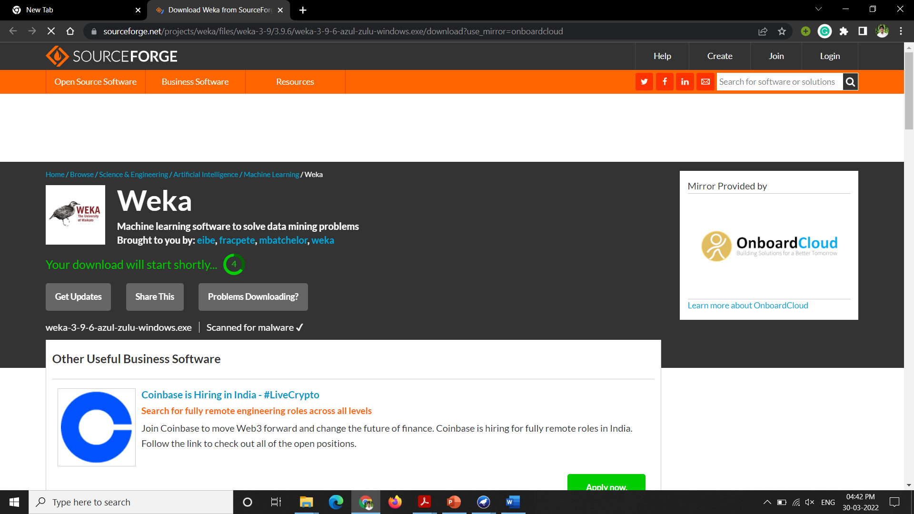

### Open WEKA explorer



### Upload the dataset to apply the apriori algorithm

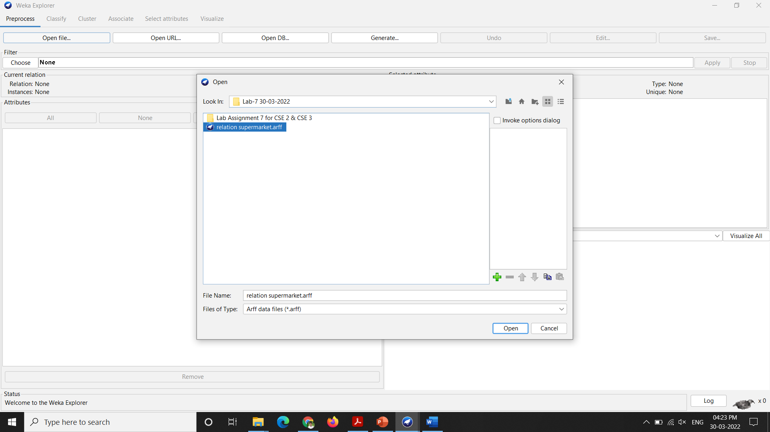

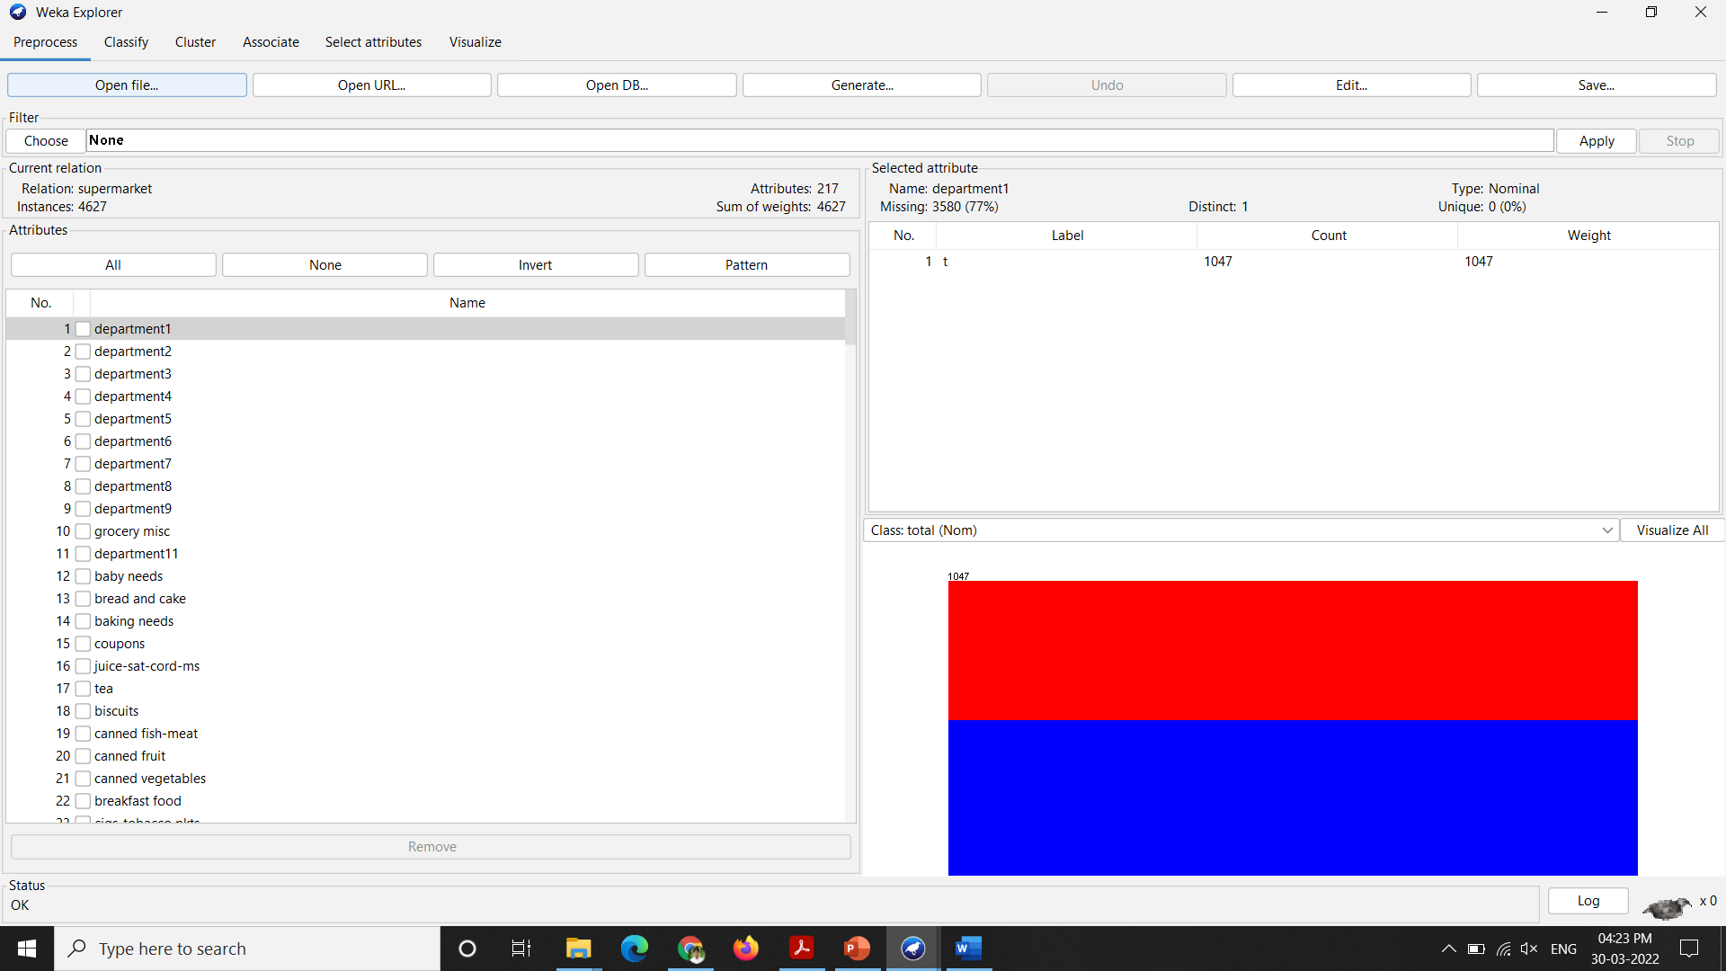

### Set different parameter values for Apriori and anaylse the results

#### Support = 0.15, Confidence = 0.9

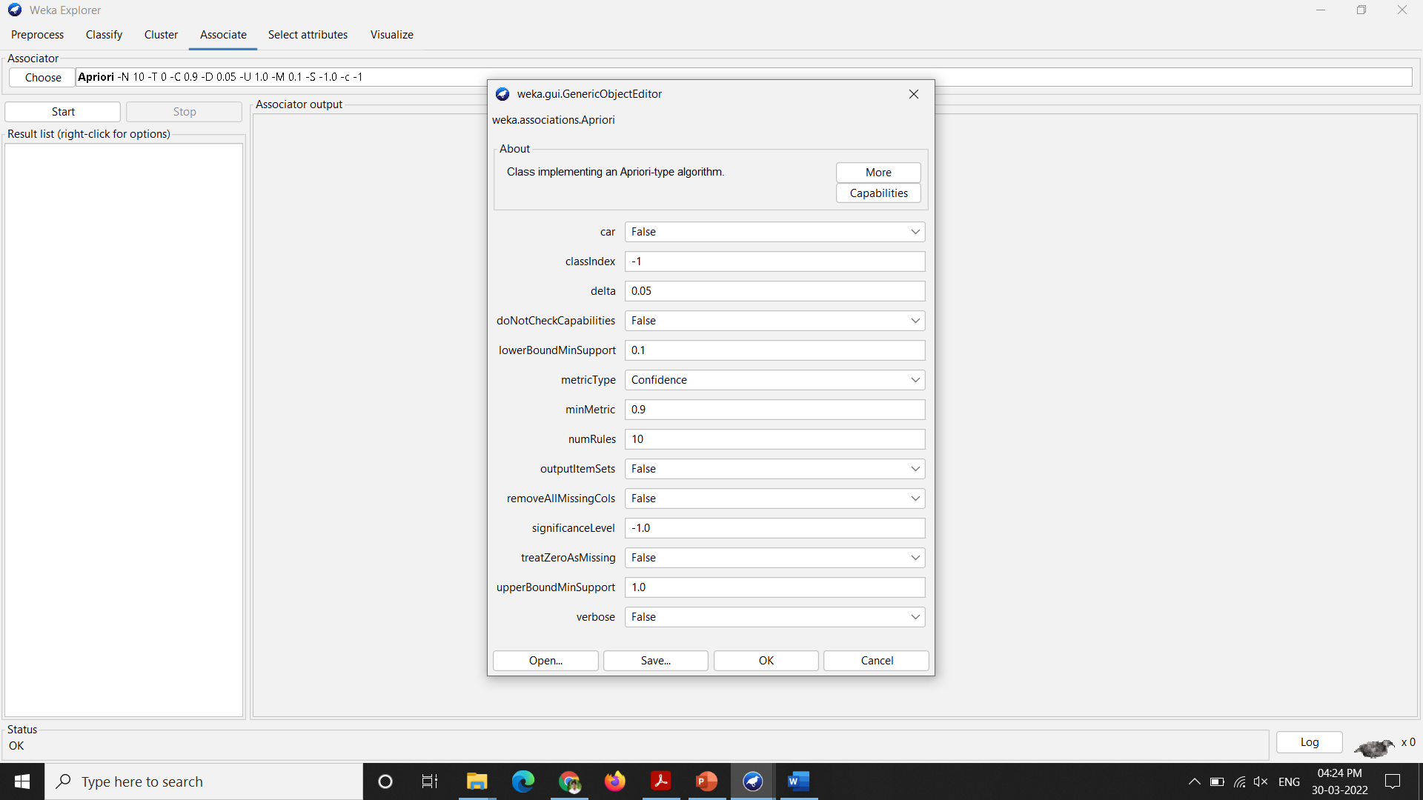

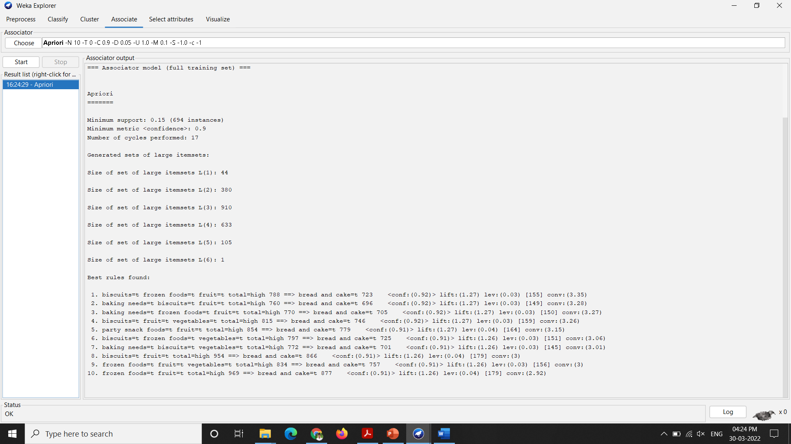

#### Support = 0.3, Confidence = 0.8

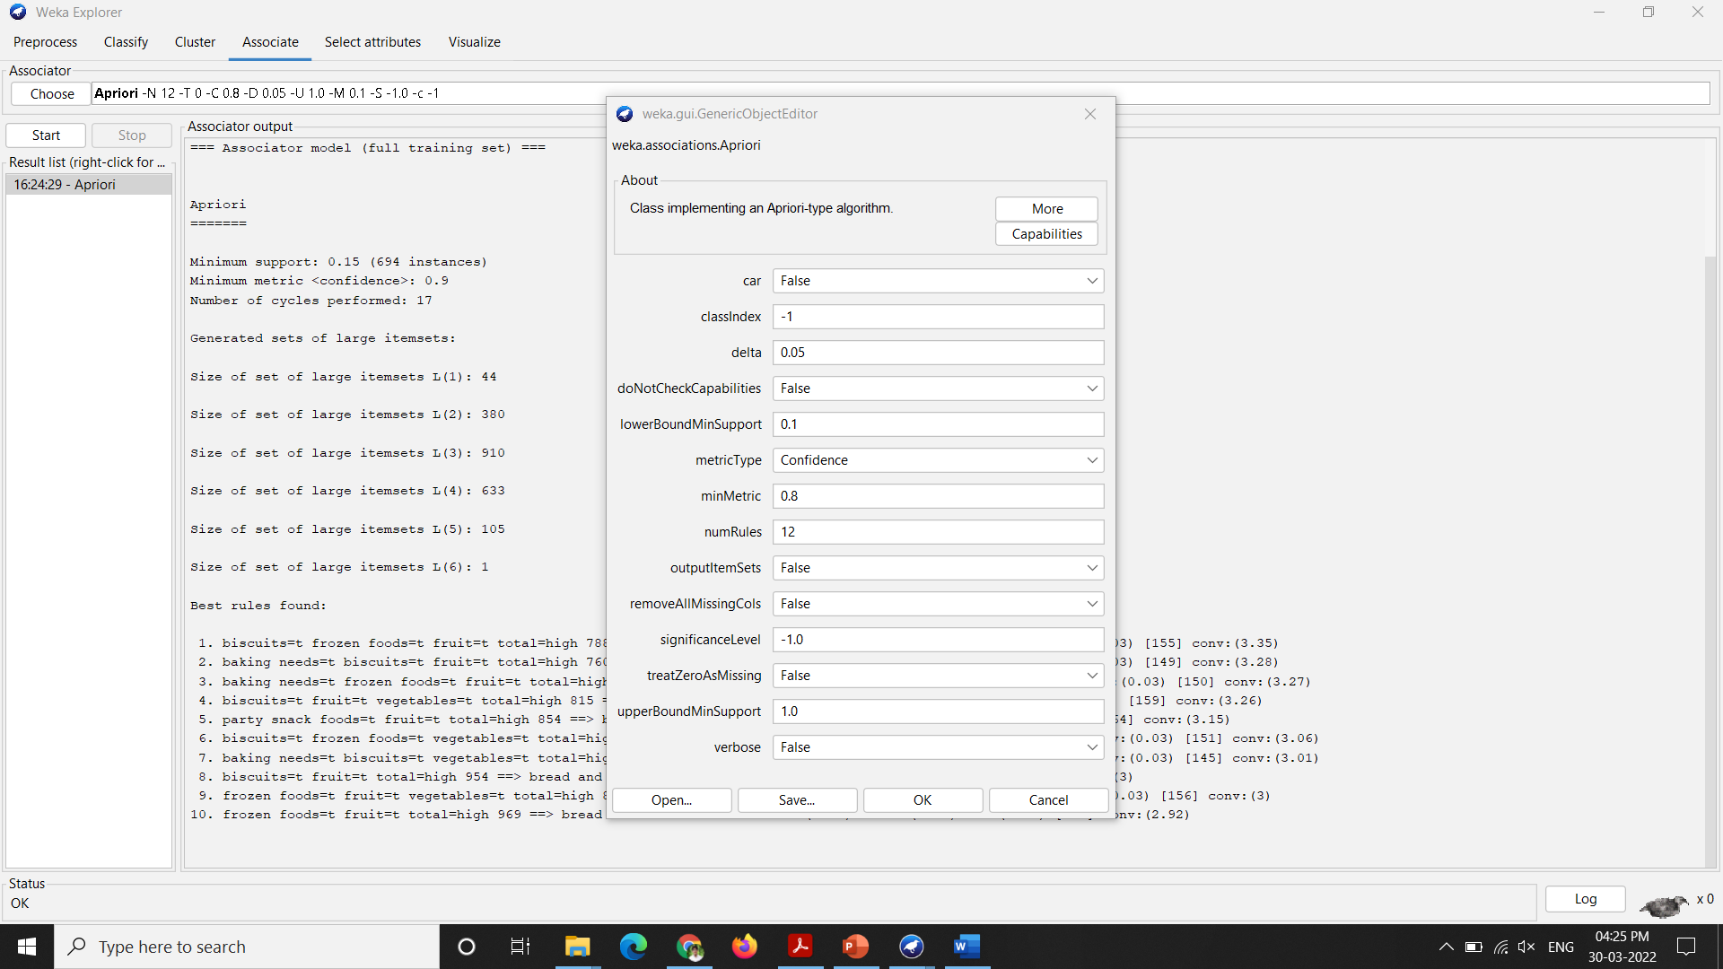

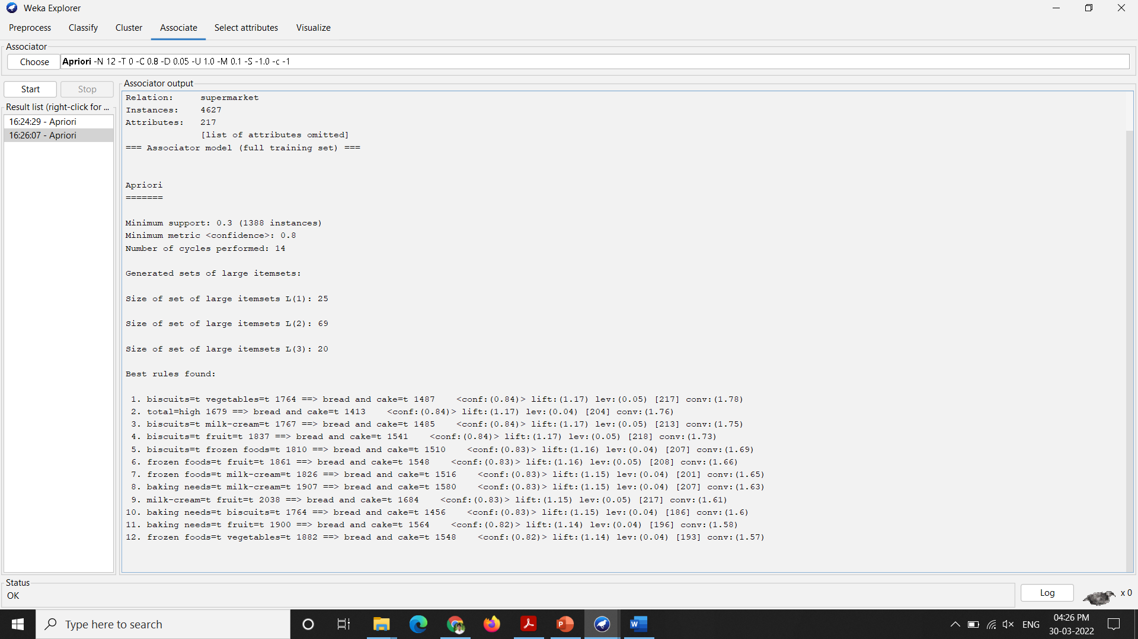

#### Support = 0.4, Confidence = 0.6

